The (Bulk) Billing Question

“Could you bulk bill me today?”
Such a simple request, such a difficult to explain system.
Bulk billing is where a medical professional (usually a doctor) accepts the Medicare rebate paid by the government as full payment for the service they have delivered. This is wonderfully convenient for the person who is being bulk billed and this is usually terrible for the income of the professional who is bulk billing.
Why terrible?
Because the rebate the government pays is less than half what the AMA calculates it should be. For example, the rebate for a 15 minute appointment with a GP is $37.05, but the AMA calculates it to be worth $78. When you are not bulk billed, the gap between the AMA fee and the rebate is your out-of-pocket expense. When you are bulk billed, the gap is income that your health professional forfeits so you benefit. Talk about a win-lose situation!
Hang on, that’s a big gap! Where does the AMA get its figure from?
The AMA has calculated what the fee would be had the government increased the rebate in line with average weekly earnings and the consumer price index (inflation). The gap has been created by successive governments (both Liberal and Labor) not increasing the rebate. For example, at present, there has been no increase in the Medicare rebate, at all, for most GP services, since 2013. Imagine if your wage was deliberately held at the same level for 4 years! Despite inflation eating away at its worth. Well, that is what the government has done with Medicare (the Medicare rebate “freeze”) and GPs and it is to stay at this level until 2020, unless the government changes its mind.
But doctors make a lot of money.
Some do, for sure, and mostly doctors earn more than the average wage. However, not as much as most people think. Roughly 1/3 goes to our practice costs, then there is more than 1/3 to holiday pay, sick pay, superannuation, tax etc. and the left over is what the doctor takes home. Beautifully discussed by Dr Elizabeth Oliver, bulk billing means the difference between taking home close to $25 for an average consultation ($70 fee) and $13 (bulk billed).
So, how come some doctors bulk bill everyone?
The same way any business offers a service for less money, usually by cutting costs, increasing turnover or simply taking home less money. Ever wondered why a bulk billing doctor rushed through a consultation? Chances are, they simply can’t afford to spend more time with you.
So, does this mean you are not going to bulk bill me today?
Yes. Unless there is a very good reason and please know that you can discuss your reason with me. Sometimes your need is greater than mine (I don’t want you neglecting your health because you can’t afford to see me) but please don’t ask because it is convenient for you or because you pay the higher Medicare Levy and believe that entitles you to be bulk billed (approximately 83% of the funding for Medicare comes from consolidated revenue i.e. general taxes, not from the Levy). What you are really asking, although you may not have realised it is “Hey Doc, can you give me a 50% discount?”

Dr Wendy Burton
27 May 2018
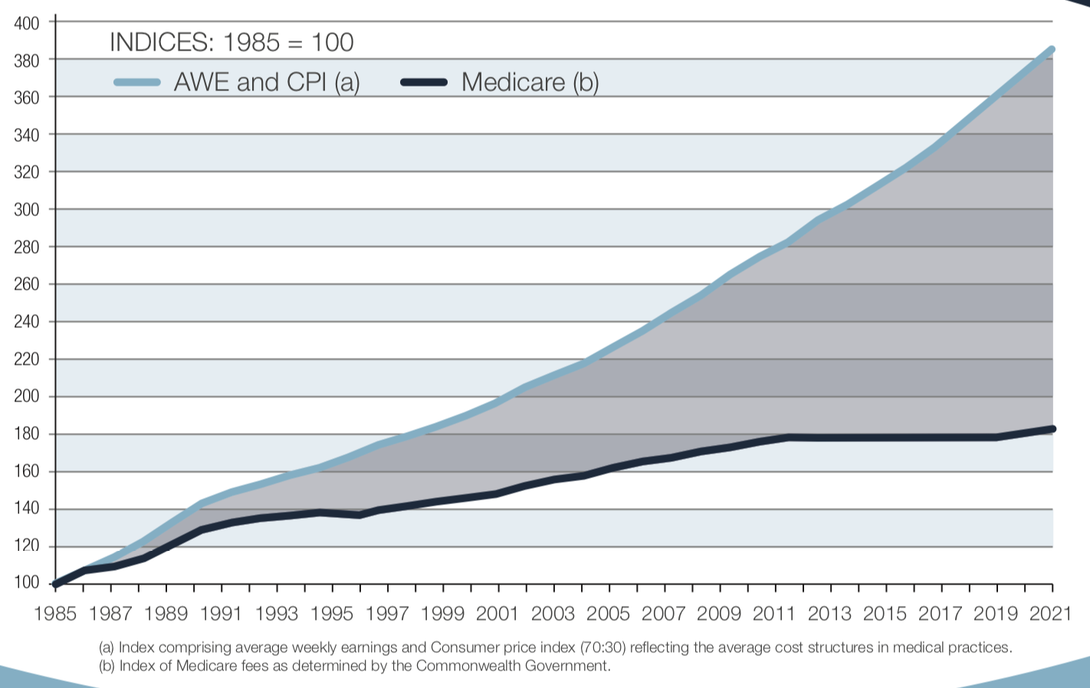
AWE = average weekly earnings. CPI = Consumer price index. Source: AMA 2016

